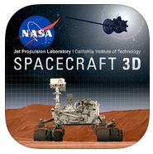
SPACECRAFT 3D APPTIVITY

In this activity you will get up close with these robotic explorers to see how they move and learn about the engineering feats used to expand our knowledge and understanding of space.
Spacecraft Name: Curiosity
Size: Size Equivalent:
Weight:
WHERE and WHEN was it Launched?
What was the purpose for launching this spacecraft?

Spacecraft Name:
Size: Size Equivalent:
Weight:
WHERE and WHEN was it Launched?
What was the purpose for launching this spacecraft?

Reflection: How does technology allow humans to collect scientific data and information on a faraway terrestrial planet?

Spacecraft Name:
Size: Size Equivalent:
Weight:
WHERE and WHEN was it Launched?
What was the purpose for launching this spacecraft?

Spacecraft Name:
Size: Size Equivalent:
Weight:
WHERE and WHEN was it Launched?
What was the purpose for launching this spacecraft?

