Math Journal Directions
 | - Open the camera app
 | - Take a picture of your math problem
 | - Open the vittle app
 | - Click add
 | - Add photo of the word problem
 | - Click Draw
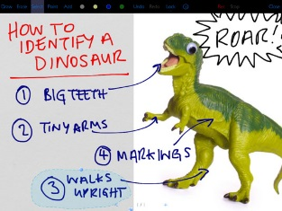 | - Solve your word problem using the draw tool
 | - Click REC
 | - Explain how you solved your problem.
 | - Click stop
 | - Click View
 | - Click save to camera roll
 | - Open Showbie and submit it in your math journal section.

